Point to Site VPN Connection

Step 1:

Create a VNet

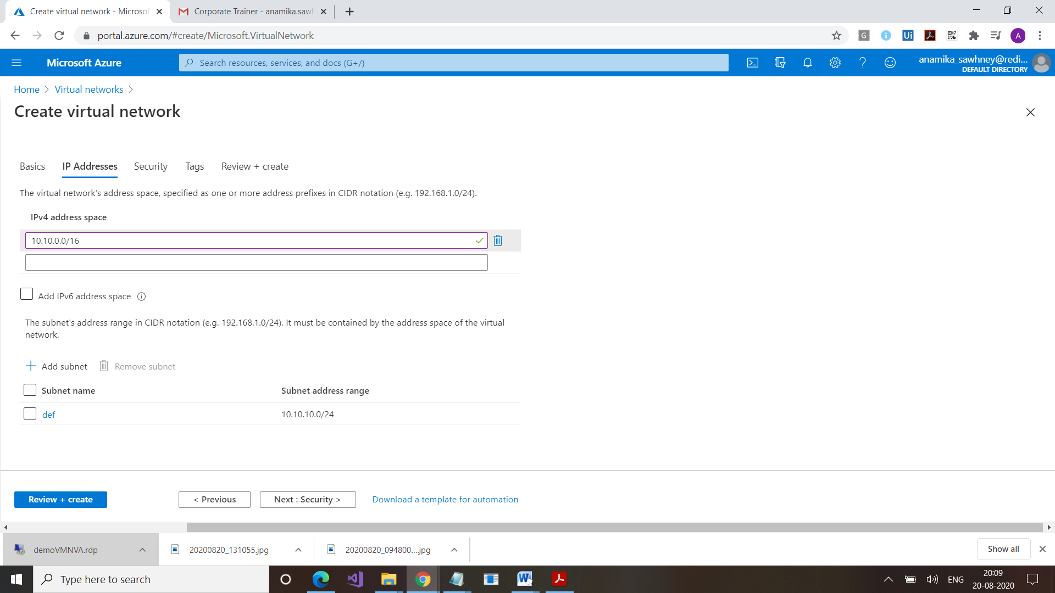

Step 2:

Go to Subnet, Click on Gateway Subnet

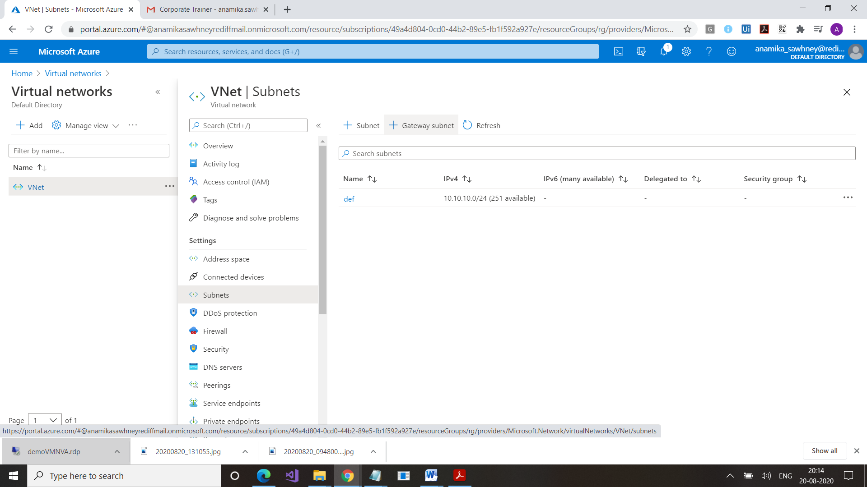

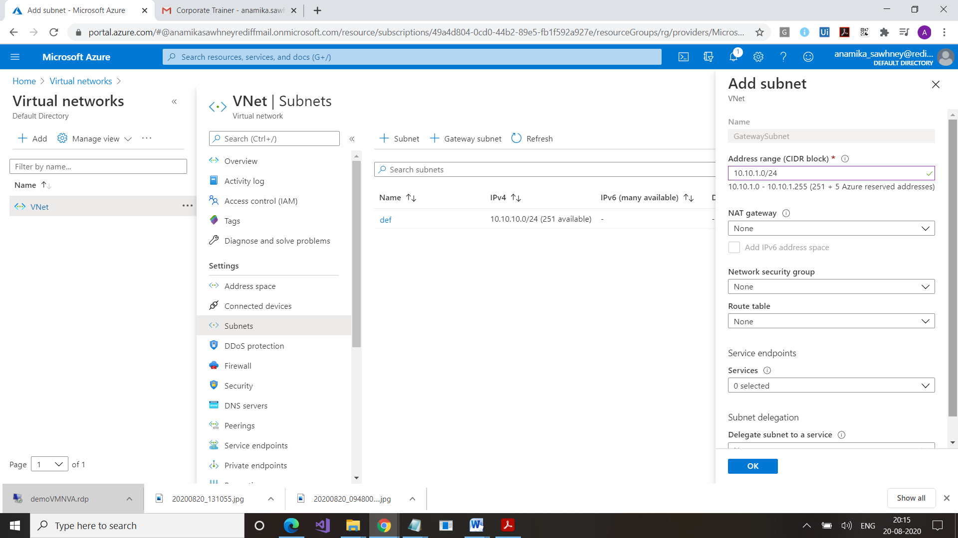

Step 3:

Now create Virtual Network Gateway

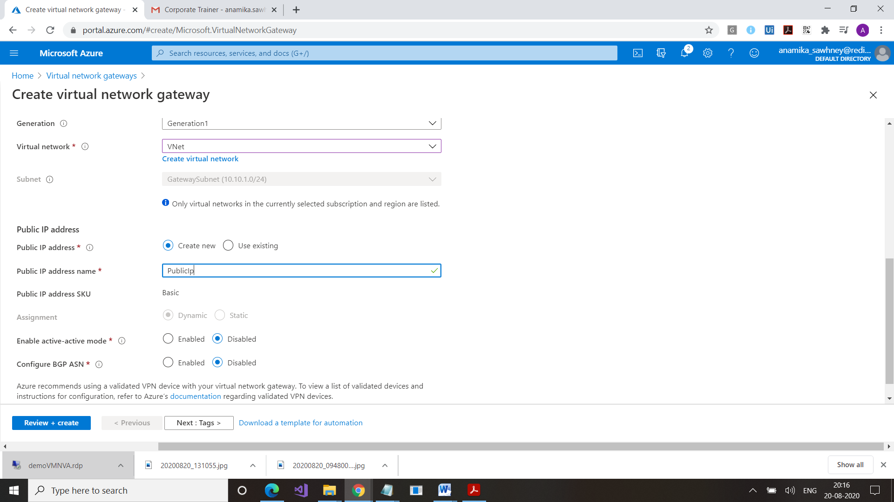

Step 4:

Create a VM

Step 5:

Create a Root certificate for VPN ,

Download it from

“<https://developer.microsoft.com/en-us/windows/downloads/windows-10-sdk/>”

OR

Use Powershell

PS C:\WINDOWS\system32> $cert = New-SelfSignedCertificate -Type Custom -KeySpec Signature `

>> -Subject "CN=EASTP2SRootCERT" -KeyExportPolicy Exportable `

>> -HashAlgorithm sha256 -KeyLength 2048 `

>> -CertStoreLocation "Cert:\CurrentUser\My" -KeyUsageProperty Sign -KeyUsage CertSign

Step 6:

Create Client Certificate

PS C:\WINDOWS\system32> New-SelfSignedCertificate -Type Custom -DnsName P2SChildCert -KeySpec Signature `

>> -Subject "CN=EASTP2SClinetCERT1" -KeyExportPolicy Exportable `

>> -HashAlgorithm sha256 -KeyLength 2048 `

>> -CertStoreLocation "Cert:\CurrentUser\My" -Signer $cert -TextExtension @("2.5.29.37={text}1.3.6.1.5.5.7.3.2")

FOLLOWING MSG WILL COME

PSParentPath: Microsoft.PowerShell.Security\Certificate::CurrentUser\My

Thumbprint Subject

---------- -------

A530EF2C779CDED03AD3D5577956C649C5C87DEF CN=EASTP2SClinetCERT1

Now open the certificates using certmgr.msc

Go to your certificates

Export

Open Root CXCert. Copy

Go to portal

Go to GateWay

Select Connections

Point to site

Address pool

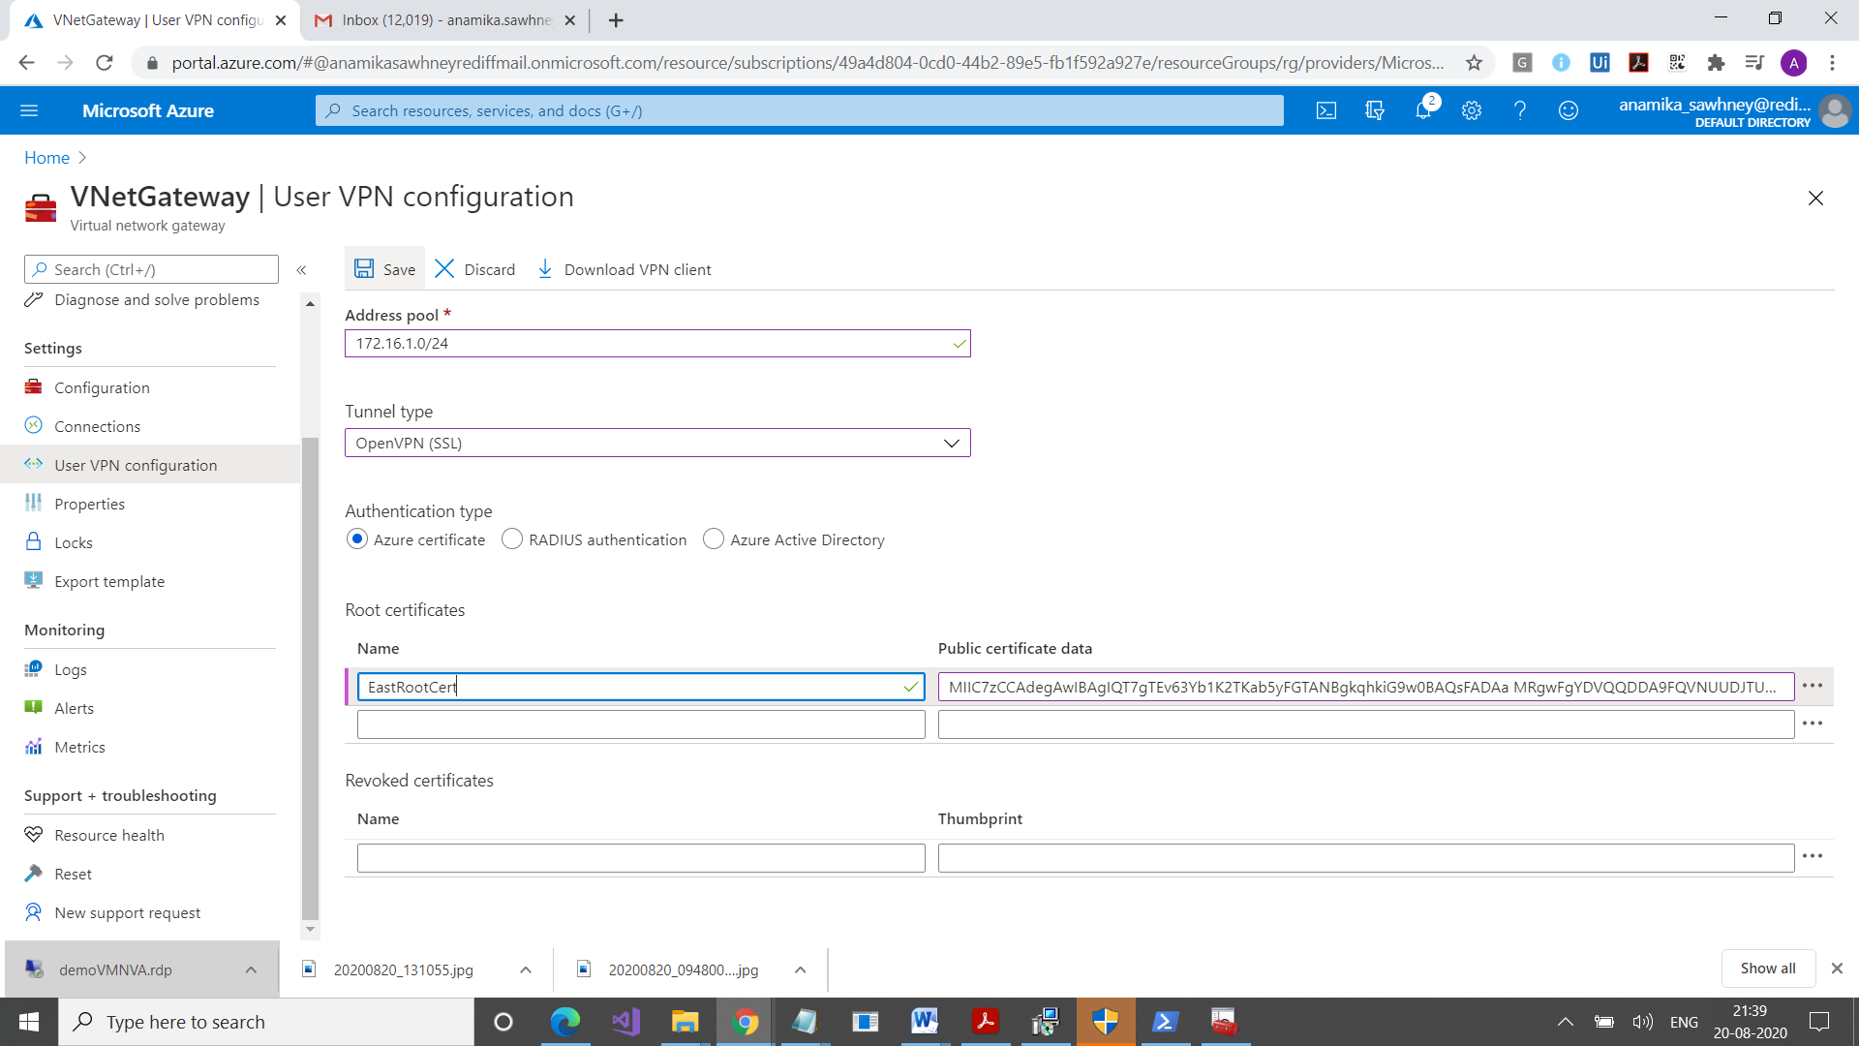

Download VPN Client

Configure the client

We have to configure two clients

Open VM or your own machine

Import Certificate

Once its imported, check it in your machine

Its connected

Get all ipaddresses

Ipconfig /all

Ping 172.16.1.2

You can connect

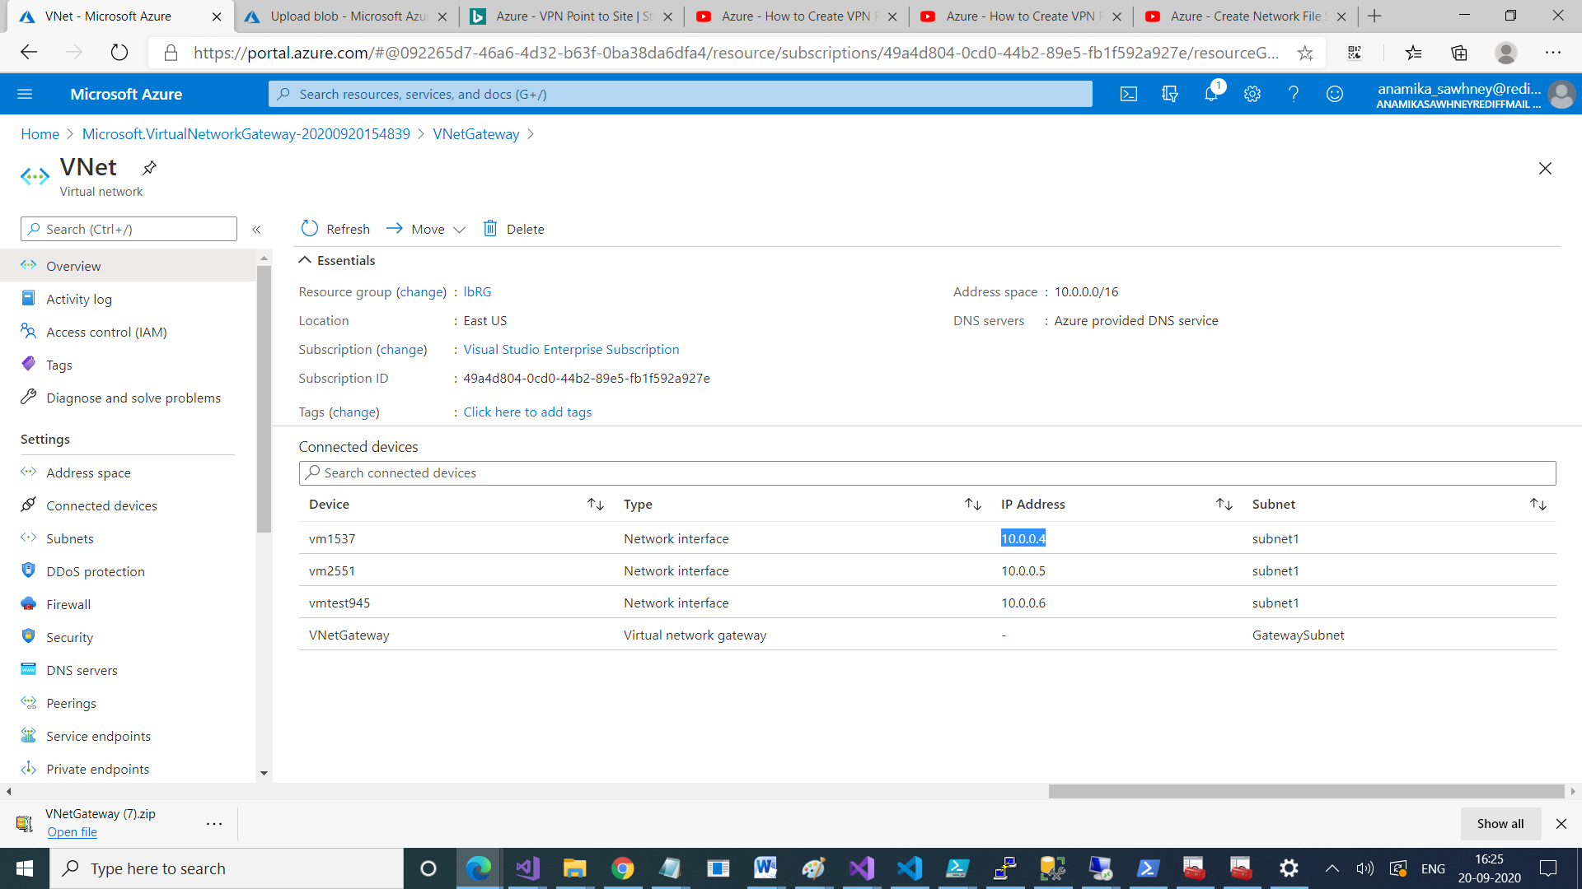

Go to VNetGateway

Select VNet

Check Subnet

Now go to your subnet, add one VM here

Install IIS

Get its pivate ip address

On your machine , use RDP , enter its Private IP Address, you can connect